***My Results of Work***

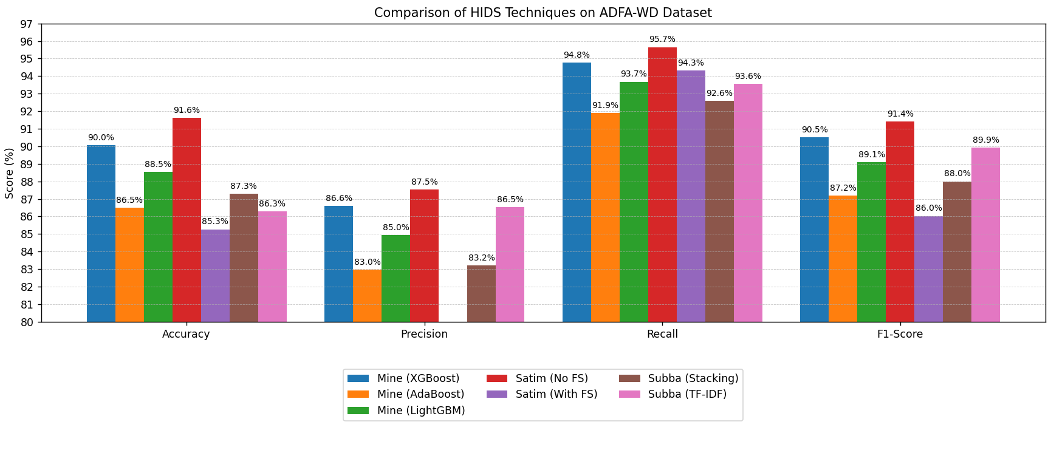

|  |  |  |  |  |
| --- | --- | --- | --- | --- |
| **Model** | **Accuracy** | **Precision** | **Recall** | **F1-Score** |
| 2025: Stacking ensemble+TF-IDF BoW (With Mutual Induction Feature Selection Technique) | 0.8527 | 0.7908 | 0.9433 | 0.8603 |
| 2025: Stacking ensemble+TF-IDF BoW (Without Mutual Induction Feature Selection Technique) | 0.9027 | 0.8613 | 0.9509 | 0.9039 |
| 2023: Stacking Ensemble-based HIDS | 0.9044 | 0.9011 | 0.9148 | 0.9080 |
| 2021: TF-IDF and SVD-based HIDS | 0.9163 | 0.8754 | 0.9565 | 0.9142 |
| Ours(XGBoost) | 0.9005 | 0.8661 | 0.9478 | 0.9051 |
| Ours (AdaBoost) | 0.8650 | 0.8296 | 0.9189 | 0.8719 |
| Ours(LightGBM) | 0.8854 | 0.8495 | 0.9368 | 0.8910 |